Name: _____________________________________ Date: ___________

**Golden Age of Greece** Mrs. Valdes

**Age of Pericles**

**To what extent did the Golden Age advancements of Ancient Athens influence other cultures?**

**GOLDEN AGE**: period of peace and prosperity in the arts, sciences, mathematics, and architecture.

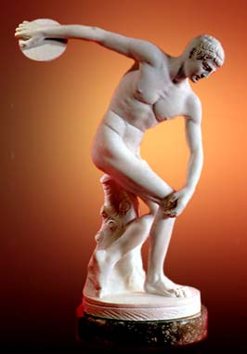

**ART and ARCHITECTURE:**

**Art:** The purpose of art in ancient Greece was for **the honor of the gods and**

**the state, not for the private pleasure of individuals**. Because Greek art

served religious and civic (government) purposes, it emphasized the dignity and nobility of

of it subjects. The first attempts to create life-sized statues out of marble in

Greece occurred around 650 BC. During the fifth century, however, artists

began to experiment with more **natural poses**. In sculptures, **Greeks viewed**

**men very realistically with natural postures. They captured bodies in**

**movement and attempted to show emotions in their sculptures. They**

**wanted to show athletically, built men and women.**

1. What are the key features of Greek sculpture?

__The poses were realistic, wanted to show movement, show athletic men and women_______________

1. How have Greek sculptures contributed to more modern art? Give an example of a specific work of art that shows

the impact that Greece art had on other civilizations.

Other artists during the Roman times copy the Greek statues and art. They show movement, emotion

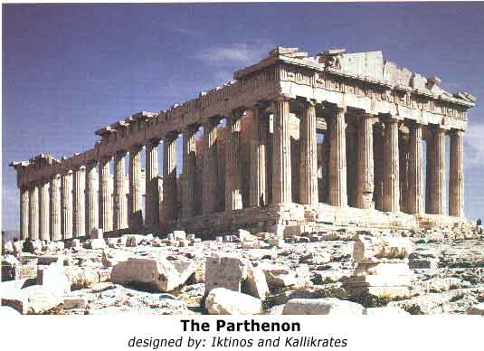**Architecture:** Although most Athenians lived in poor homes, they were

willing to invest large amounts of money on temples and other public

buildings. Among the most important buildings constructed during the

fifth century is the **Parthenon.** It was built to honor the goddess Athena

and to celebrate the end of war with Persia during the reign of Pericles. The

Parthenon represents the best of Greek architectural style, emphasizing

proportion and order. The Parthenon was constructed out of **marble** and

its most distinct feature is the use of **columns**.

1. What are the key features of Greek architecture?

**_Marble and columns were used on temples and government buildings**

2.Why is Greek architecture a major contribution to society? Provide at least one example that reveals Greek architecture’s influence on another civilization.

**Lincoln Memorial, White House, government buildings copy the Greek architecture to honor the Greeks for giving the world a democratic form of government**

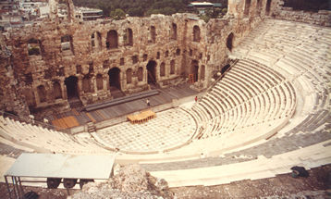

**DRAMA: Theater**

It has been said the Western drama owes its beginnings to

the Greeks. The Athenians developed two types of plays,

**comedies** and **tragedies**. Tragedies always had to do with

the suffering of great individuals, not that of ordinary men

and women. Greek drama also focused on universal

problems and used material familiar to the audience.

Athenians plays were staged in outdoor theatres called

**amphitheaters** made out of marble.

1. In what ways does this theatre resemble modern theatres you see today? Give an example.

**____Jones Beach Theater is shaped the same way**

__________________________________________________________________________________________

1. Why do you think the Greeks created the amphitheaters in this shape?

**___It projects the sound, it makes it sound louder___________________________**

1. What examples do you see in other civilizations that show the use of comedies and tragedies?

**Comedy-Modern Family Tragedies-The Walking Dead**

**MEDICINE AND SCIENCE**:

* **Thales** was a great Greek astronomer and scientist, created the first two steps of the

scientific method- collecting information and forming a hypothesis-educated guess.

* **Pythagoras** made many achievements in geometry, specifically the

**Pythagorean Theorem**. **(a² + b² = c²)**

* **Hippocrates** is known as the **“Father of Medicine”** and created the **Hippocratic Oath**

that all doctors must take before becoming practicing doctors.

* + “I will give treatment to help the sick to the best of my ability and judgment…

I will not give illegal drugs to anyone if I am asked…nor will I give a women means

to procure an abortion…Whatever I see or hear which should not be spoken to any

person outside, I will never divulge…” – Hippocratic Oath

1. Why would Thales creation of the scientific method be a huge impact on society? Provide an example of the

impact that it has on future civilizations.

_____________________________________________________

1. Why is the Pythagorean Theorem a major achievement of the Greeks? (DON’T JUST SAY BECAUSE WE

STILL USE IT TODAY IN MATH) – Be specific why is this important?

**__________________________________________________________________________________________**

__________________________________________________________________________________________

1. How does the Hippocratic Oath impact other civilizations? Explain.

**__________________________________________________________________________________________**

__________________________________________________________________________________________

**WRITERS OF HISTORY:**

**Herodotus** is considered the “Father of History” for writing history based on the information he collected from eyewitnesses.

**Thucydides** is considered the 1st scientific historian trying to avoid bias in his writings.

**Homer** wrote epic poems such as the *Iliad* and the *Odyssey* that inspired many later writers.

1. Provide examples that reveal the impact that these writers had on other civilizations. (Hint: What occupations today

might there be today that get their ideas from the Ancient Greeks?)

**__________________________________________________________________________________________**

__________________________________________________________________________________________

**GREEK PHILOSOPHERS –“LOVERS OF WISDOM”**

Greek thinkers used **observation and reason** to understand why things happened. **Socrates** has often been called “The

Father of philosophy” even though he never wrote a world or developed any system of thought. His lasting legacy to

Philosophy was to develop what has come to be known as the “**Socratic method**” an approach that used questions

and answers to refute the opinions of others and to lay the foundation for true knowledge. In essence, the Socratic Method

helps you learn about beliefs and ideas by **asking questions**. Socrates, however was put on trial for atheism and for

corrupting the youth of Athens and was put to death for his crimes by the government.

1. Who (what occupations) still uses the Socratic Method today? Give examples.

**__________________________________________________________________________________________**

__________________________________________________________________________________________

1. Why do you think the government would put Socrates to death?

**__________________________________________________________________________________________**

__________________________________________________________________________________________

**Plato** was the student of Socrates and believed in objective truth that could only be found after a long search. He founded

the Academy, which was one of the great philosophical schools of the ancient world.

**Aristotle** was also a famous philosopher who believed in using one’s senses to discover the

laws that govern the physical world. He was the first to classify plants and animals and he added ‘the third step

of the scientific method – testing the hypothesis to see if it was correct

1. Why are these philosophers’ ideas still considered important today? Explain.

___________________________________________________________________________________________________________________________________________________________________________________________________________________________________________________________________________________________________________________________________________________________________________